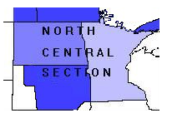 |  | - North Central Section  - MAA  - Fall 2019
Vol. 22 No. 2 |  | In This Issue
Call for Nominations
Deadline: February 15, 2020

Meritorious Service Award
Information: http://sections.maa.org/northcen/awards/service/service.html
Send nomination to: zobitz@augsburg.edu

Distinguished College or University Teaching of Mathematics
Information: http://sections.maa.org/northcen/awards/teaching/teaching.html
Send nomination to: jahn@csp.edu

Report from Fall Meeting
Upcoming Meetings
Spring 2020: St. Olaf College, April 17-18, 2020
Fall 2020: Augustana University, October 16-17, 2020

Page 2

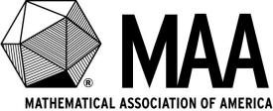
Report from the MAA Congress
Jason Douma
Page 3 and 4

Report from Summer Seminar
Namyong Lee
Page 4

Officer Reports
Page 5 and 6

News from the Section
Page 7 and 8
Thanks to Concordia College, Moorhead, Minnesota for providing a smoothly organized and enjoyable meeting!

Report from the Fall 2019 Meeting
There were 63 in attendance with 39 faculty, 14 undergraduates, 8 graduates and 2 industry.
Dr. James Sellers provided a very interesting opening invited talk about convergent Infinite Series, helping the audience find some exact results. James is the secretary of the MAA, but also has recently taken a position as department head at University of Minnesota Duluth, so we hope to see him at future meetings! 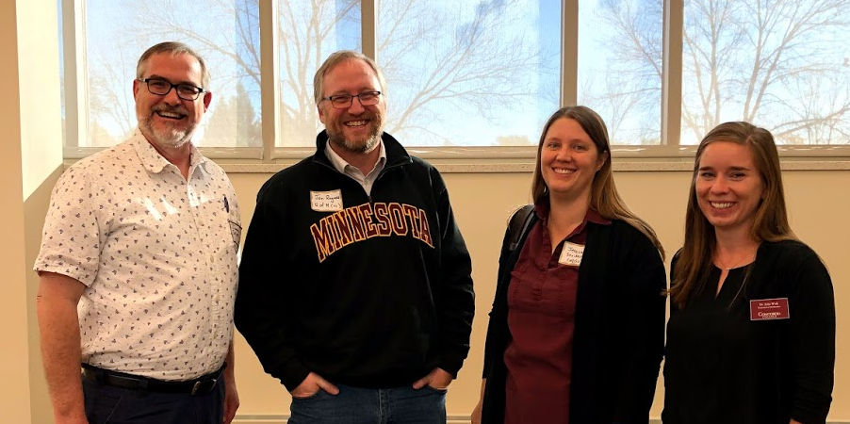
Contributed talks on Friday talked about Markov and playing Farkle to filling space with polygonal shapes (“My God, it’s full of dots!”- see john-art.com)
Saturday opened with a talk by Dr. Jessica Striker about Mind-boggling Toggling.
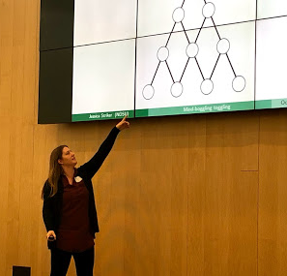
The afternoon continued with a section NExT panel on Starting or Leading a Math Club, and some high quality research talks.
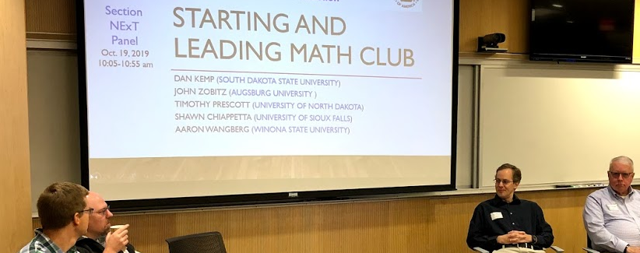
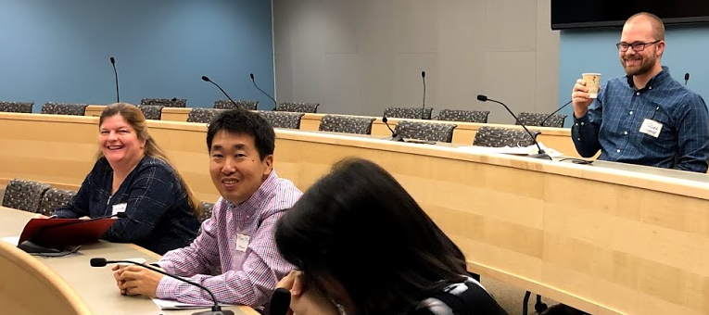
Dr. Aaron Wangberg, winner of the 2019 MAA-NCS Distinguished Teaching Award, gave a talk on Rethinking the Role of “math” in the Mathematics Classroom, bringing along some of his 3D models to help illustrate his points. 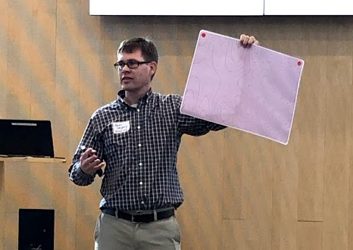
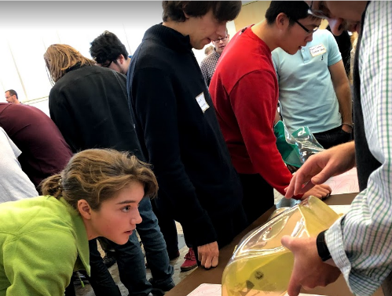

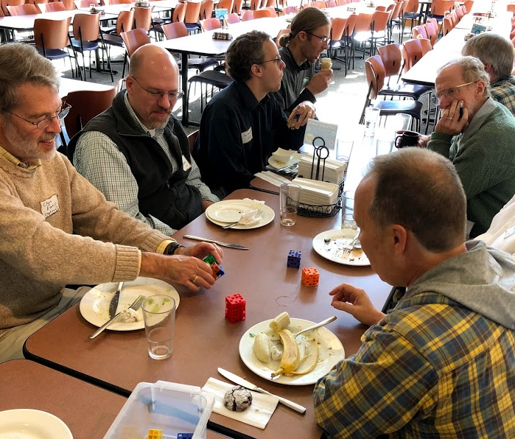
For more pictures: https://photos.app.goo.gl/i52KkaVGcnnpFSHWA

Dr. Gerald Hauer was honored at the business meeting with the Lifetime Achievement Award. Jerry will be retiring after 28 years single-handedly running the NCS TEAMS test- the test was renamed in his honor.
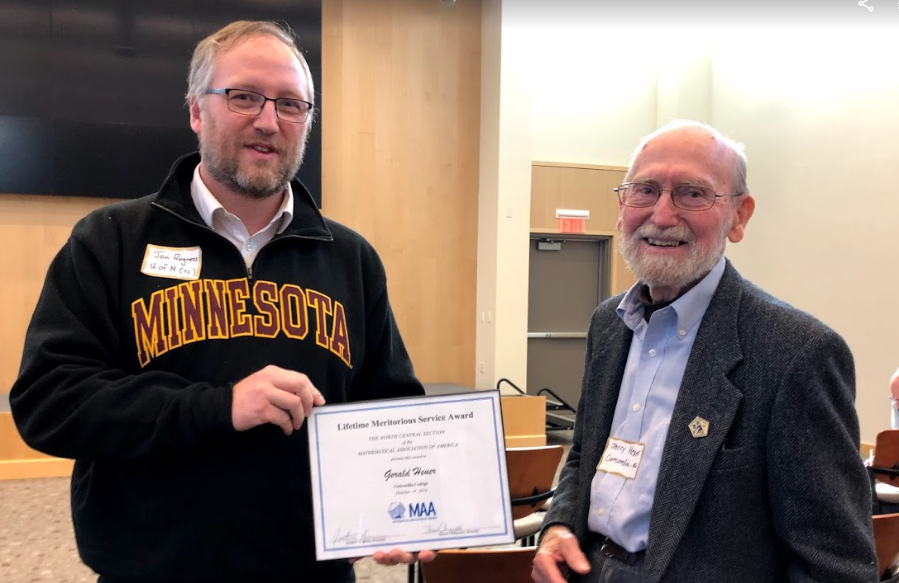
The afternoon ended with excellent research and teaching talks.
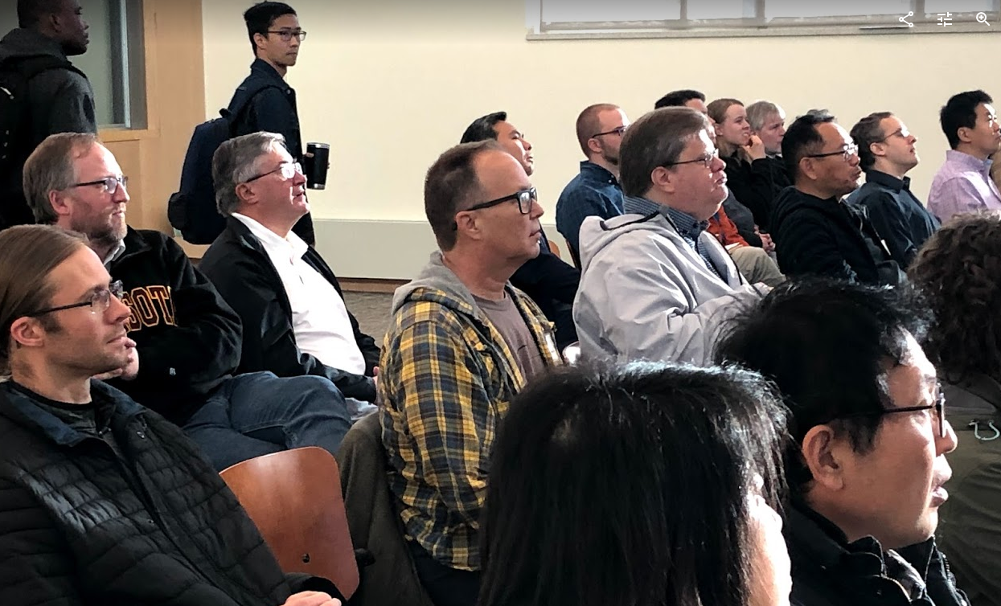
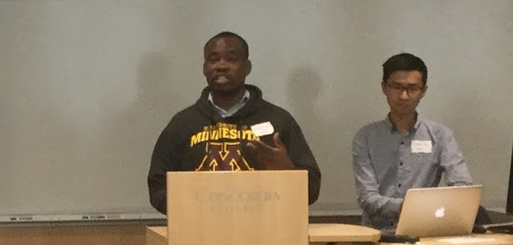
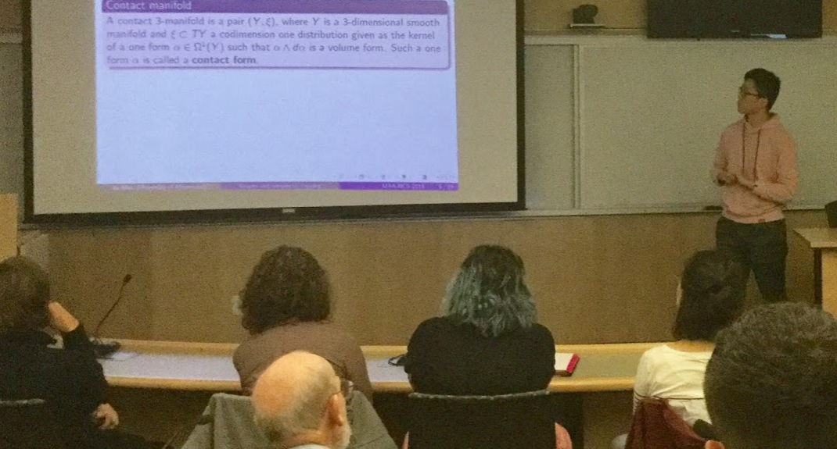
Special thanks to Julia Walk, chair of the Local Organizing committee and members Doug Anderson and Dan Biebighauser.
Meeting site:
http://sections.maa.org/northcen/meetings/meetingFall2019.html
The MAA Congress met on July 31, 2019, in Cincinnati, just prior to Mathfest. The annual meeting of Congress each summer provides an opportunity for MAA staff and volunteer leadership to provide updates on key programs and initiatives within the organization, as well as time for dialog on areas of need and issues of strategic interest to the MAA.

Report from the MAA Congress

Members of Congress were also provided with extensive study materials in advance of the summer meeting. This, along with a series of online “office hours” hosted by Michael Pearson (Executive Director) and Su Dorée (Chair of Congress) for members of Congress on a periodic basis, enabled members of Congress to conduct a productive meeting in spite of the considerable time constraints.
While the MAA does face certain limitations (particularly financial constraints), I am continually—and increasingly—impressed by the work of member-volunteers throughout the association, whose efforts make it possible for the MAA to have the impact of an organization many times our actual size (and budget).
Here are some highlights from the 2019 meeting of the MAA Congress. This list is not comprehensive, but tries to capture those items that may be of interest to members of our section.
* To promote interaction, we experimented with round tables—rather than rows of chairs—in many of the session venues at Mathfest. (What did you think of the change?)
* MAA Connect, the association’s new platform for online interaction and community-building is now being rolled out to select audiences.
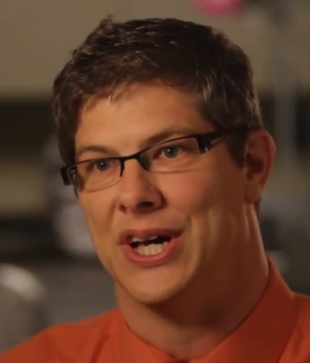
* We have added three new SIGMAAs in the past year (Mathematical Knowledge for Teaching (MKT), Mathematics and Sports (Sports), and Recreational Mathematics (Rec). This brings the total number of SIGMAAs to seventeen.
* Congress and the Board of Directors are exploring ways to promote micro-volunteering opportunities for our members. Unlike committee assignments or other long-term commitments, micro-volunteering involves jumping in to perform a well-defined short-term task that would typically require only 1-3 hours to complete (e.g., reading policy statements for the MAA and giving feedback, refereeing articles, judging posters). By finding ways to make these opportunities more visible and easier for members to “grab,” the MAA hopes to give more members an opportunity to make a bigger difference without the pressure of a major time commitment.
* The association has added a new MAA Award for Inclusivity, which will be awarded annually to a person (or persons) who has performed significant, sustained work to broaden access to mathematics. The first recipient of this award, announced at Mathfest 2019, was Sylvia Bozeman.
* Michael Pearson led a discussion on the MAA’s transition away from participation in the Joint Mathematics Meetings. At this stage, the emphasis is on identifying ways to support activities and programming within sections and communities of the MAA that could not be supported if the MAA were still subsidizing the JMM. Members of Congress raised some concerns that SIGMAAs, in particular, could be adversely affected by the move away from the JMM.
* The MAA reported total accumulated net assets of $14,000,000 and a 2018 FY net operating surplus of $858,000 (aided by a couple of large bequests). This is a great improvement in our financial status, compared to the previous year.

* The MAA Board of Directors has given final approval to the association’s mission, core values, and vision statements. The mission of the MAA is to advance the understanding of mathematics and its impact on our world. The core values are: community, inclusivity, communications, and teaching and learning. Vision: We envision a society that values the power and beauty of mathematics and fully realizes its potential to promote human flourishing. These statements were developed from prior input provided by Congress.
* Congress approved two new goals, recommended by the MAA staff and Board of Directors.
Goal: To curate and develop our robust portfolio of programs that expand MAA’s outward facing impact. (This refers to MAA-administered programs that are funded by external grants/organizations.)
Goal: To celebrate the power of mathematics on an international scale through successfully hosing the 2021 IMO in Washington, DC, and leveraging the event to strengthen the reputation of the MAA.
While there was some robust discussion (as only a room full of academics would understand) about whether these goals appropriately match the other existing goals in scope and language, and whether the second proposal goal is technically a “goal” at all, the Congress supports their intended purposes and approved the new goals.
* Based on recommendations from an internal task force, Congress approved changes to its bylaws concerning at-large representative. The change increases the number of at-large representatives from 6 (2 for minority interests, 1 for business, industry, and government, 1 for teacher education, 1 high school teacher, and 1 Canadian), to 8 (3 for minority interests, 1 for business, industry, and government, 1 for teacher education, 1 high school teacher, 1 international, and 1 for community college interests).
* As suggested by the new strategic goal, the MAA will play a leading role when the United States hosts the International Mathematical Olympiad in 2021.
* Su Dorée solicited and received responses to the prompt “I wish the MAA…” Sixty-four responses/ideas were received. These are being shared with MAA staff, Board of Directors, and Congress for possible follow-up.
* Congress held elections for offices whose terms will begin on February 1, 2020: Chair (Tim Chartier), Recorder (Therese Shelton), Elections Committee (Jennifer Galovich, Thomas Hagedorn, Pam Wovchko). Congress also recommended candidates to the Board of Directors for selection to the MAA Nominating Committee. (Because those appointments are made by the Board, there are no “results” to announce here.)
The Cincinnati meeting was packed with information about projects, programs, and goings-on in the MAA. We are an active organization (very active!), and there is no reasonable way to even summarize extent of programs and resources supported by the MAA in a brief report such as this. Instead, I will choose to recommend an activity for each of you.
When you find a free moment (or when you need an excuse to procrastinate before tackling the stack of papers that need to be graded), visit the MAA website (www.maa.org) and select the “Programs and Communities” pull-down menu. If you do some exploring within these subcategories you will almost certainly discover some resources, projects, and communities you did not previously know about, and—I hope—you may discover a new opportunity to engage with the people and resources of the MAA.
And speaking of engaging with the people of the MAA: our organization has scores of interest groups and committees that are regularly in need of new members. I would be happy to visit with you about these opportunities if you think you might have an interest in serving.
Please do not hesitate to contact me with your questions about developments in Congress or the national level of the MAA. (I may not know the answer myself, but I will help you try to find it.) I also welcome hearing your suggestions or perspectives that may help inform the ongoing work of the greater MAA organization. My email address is jason.douma@usiouxfalls.edu.
Submitted 15 October 2019
Jason Douma

Report from Summer Seminar
Overall, we had a very successful summer seminar (at least in terms of enrollments and finance). We had 29 paid participants + 5 facilitators (=seminar leaders) + 1 assistant + 2 plenary speakers + 7 undergraduate students in the panel session.
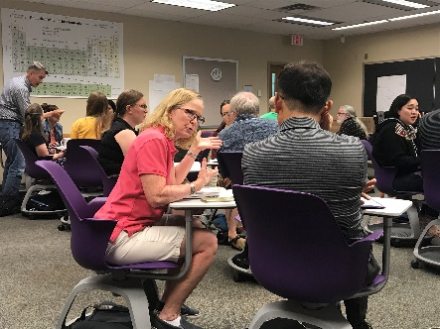
This summer seminar was also co-sponsored by AIBL (http://www.inquirybasedlearning.org/) and we shared the cost. Basically the facilitators' honorarium and outside travel was covered by AIBL, and any local logistics was covered by NCS.
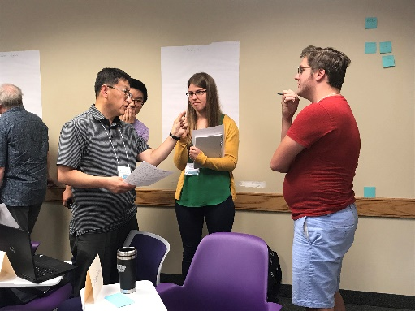As a result, we ended up with over $1,000 profit from this summer seminar.
As a result of the summer seminar, we formed an online community which is also supported by our facilitators. Look for more information from participants at the Spring 2020 meeting!
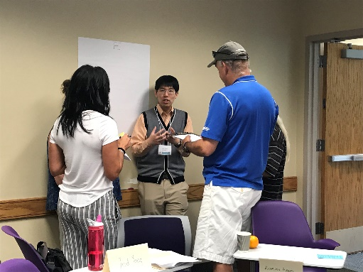Look for an article with more information about summer seminar in a future MAA Focus Section Happenings article!
Namyong Lee

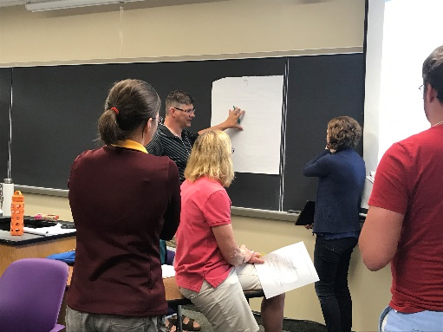
Officer’s Reports
President

Treasurer
General fund balance: $14,144.27
Notes: The cost for hosting a meeting for some schools has increased because some institutions charge a fee for use of space. This extra cost should not prevent a campus from agreeing to host the meeting, so to help cover the cost, the regular registration fee was increased last year.
Update on registration fees
- Regular member: $25
- Retired member: $15
- Student or Invited Speaker: free
Our section will fund a National Project NExT fellow for 2020.
Summer Seminar fund balance: $299.30
Notes: The last summer seminar yielded a positive revenue which has removed the negative balance held for many years.
Section NExT fund balance: $2,355.53
Notes: Thank you to Institutional Members who continue to support the work of Section NExT. Requests for 2020 memberships will be coming out near the end of the year.
Justin James
Minnesota State University- Moorhead

Information Officer
This is my first year as the Information Officer and I am learning quite a bit as the year progresses. My hope is to maintain and update the website so that it is useful to the members of the Section throughout the year, not just close to meetings times. If you have anything to share that would useful for members of the NCS section to know - MAA related or not, please send that information to me. I will do my best to keep the website up to date so it will have value to you. Take a look at it now and if you have any recommendations, please share them with me!

http://sections.maa.org/northcen/

Donna Flint
South Dakota State University

Section NExT
For Fall 2019, we welcomed 5 new section NExT fellows. Please help them feel welcome here in our section.
Sarah Seger, (Concordia College)
Jeremiah Bartz, (University of North Dakota)
Kyung Il Lee, (Minnesota State University, Mankato)
Jeff Ford, (Gustavus Adolphus College)
Erin Brownlee, (Northern State University
For the fall 2019 meeting (October 18-19, 2019, Concordia College), Sarah Seger, Jeremiah Bartz, and Kyung Il Lee joined members of the Section NExT leadership team for a networking dinner prior to the meetings and then Section NExT held a special panel session on "Starting and Leading a Math Club" with Dan Kemp (South Dakota State University), John Zobitz (Augsburg University), Timothy Prescott (University of North Dakota), Shawn Chiappetta (University of Sioux Falls), and Namyong Lee (Minnesota State University, Mankato) as panelists.
Section NExT will invite Julia Walk (Concordia College) as the section NExT speaker for the Spring 2020 meeting (April 17-18, 2020, St. Olaf College). New Section NExT fellows Jeff Ford and Erin Brownlee plan to attend the Spring 2020 meeting.
Section NExT leadership team

Concordia College- Moorhead

News From the Section

Concordia College-Moorhead welcomed two new tenure-track faculty to the mathematics department this fall of 2019.

Greg Tanner received his PhD in Applied Math and Computational Sciences from the University of Iowa and has interests in numerical methods for differential equations. (note from the editor- Greg is a well-remembered alumnus of South Dakota State University)

Sarah Seger received her PhD in Mathematics from Rice University and has interests in knot theory and low-dimensional topology.

John Reber is leaving to pursue work in data analytics. Xueqi Zeng retired after teaching at Concordia from 1990-2019. Nathan Axvig has gone to a half-mathematics and half-computer science position, split between the mathematics department and the Offutt School of Business.

University of Minnesota- Duluth

UMD welcomes new faculty:

Seth Hovland
Seth graduated with his Masters in Applied and Computational Mathematics from the University of Minnesota Duluth. In his research, he worked with Dr.Buckalew. The goal of his research was to use mathematics to fight partisan gerrymandering. Seth has a passion for mathematics because it is truly applicable anywhere, from politics to physics. This year he feels privileged to share his passion with UMD students.
Seth has lived in Duluth nearly all of his life. He feels that it is easy to love living in such a beautiful place. Seth enjoys hiking the trails along Skyline in the fall, cross-country skiing in the winter, and camping in the BWCA in the summer. Seth is currently applying to mathematics doctorate programs for next year all around the country. He is hoping that in continuing his education, he will have further opportunities to research and apply mathematics.

Dr. Xiaoyin Li
Xiaoyin Li started her research in Statistics in Paris after receiving her B.S. in Mathematics from China. She has a Master's degree in Statistics from Paris 6, Université Pierre et Marie Curie. She obtained her PhD in Statistics from University of Cergy-Pontoise in France, under the supervision of Dr. Paul Doukhan. Before joining UMD, Xiaoyin was a postdoc fellow in Biostatistics at the Department of Population and Quantitative Health Sciences, School of Medicine, Case Western Reserve University in Cleveland. Her research is on prediction of time series, statistical learning, discrete valued processes, and statistical genetics. In her free time, Xiaoyin enjoys cooking and painting.

Dr. Igor Melnykov
Igor earned his Ph.D. in Statistics from Bowling Green State University in 2005. He also holds an Engineering degree from Kharkov State Polytechnic University in Ukraine. His research interests are in the area of cluster analysis and classification with the focus on mixture models and EM algorithm. He has done research on multiple hypothesis tests and enjoys working on real-life applications of statistics and consulting.
Born in Ukraine, Igor moved to the US in 1999. Before joining UMD, he worked at Colorado State University - Pueblo and at Nazarbayev University in Kazakhstan. In his free time, Igor enjoys hiking and exploring the forests of Northern Minnesota. He also likes to play chess and read sci-fi books.

Dr. James Sellers
James joined the department as the new Mathematics & Statistics Department Head. James earned his PhD from Penn State University in 1992. His research focus is primarily in number theory (integer partitions) with additional work in enumerative combinatorics.
Prior to moving to Duluth, James lived in State College, Pennsylvania where he was a member of the faculty in the Mathematics Department at Penn State. He had returned to Penn State in 2001 after nine years away at another university. Outside of teaching and research, he enjoys spending time with his family – his kids and his two granddaughters (Emma, who is 4 years old, and Sophia, who is 2.5 years old). He also enjoys playing softball and racquetball. In his “spare time”, he very much enjoys playing Candy Crush (and he’s not embarrassed to admit it!)

Augsburg University
Thanks to everyone for a great spring meeting -- our first at Augsburg!
We are continuing our work on the calculus sequence supported by the SUMMIT-P project. If you're interested in the activities/labs or want to come visit a class, just let us know.
We are pleased to welcome two new CS faculty this year, Amy Larson and Nimanthi Atukorala.
Also new this fall is a minor and focus area in Data Analytics.

South Dakota State University
Faculty member Dan Kemp retired effective January 2019 after 42 years of service. Though his active involvement in the department and teaching Honors classes will be missed by faculty and students, he remains active by advising students in research projects, advising the math club, and substituting when needed.
SDSU has recently been approved to offer a Mathematics BS degree with Data Science Specialization, as well as a BS degree in Data Science and AS degree in Data Science. All three degrees prepare students for good (yet different) careers. In addition, the graduate Data Science Certificate has been updated for those who work with data in their jobs, but desire a credential to update their portfolio. The three existing master’s degrees in Mathematics, Statistics, and Data Science and the Ph.D. program continue to prepare students for excellent professional opportunities that make good use of their quantitative expertise.

Minnesota State University- Mankato
The Department of Mathematics & Statistics had several new faculty searches in the last Spring 2019, and found three new faculties from this Fall 2019. They are Dat Cao (Partial Differential Equations, Harmonic Analysis), Soumya Banerjee (Algebraic Geometry), and Tyler Metzger. However, an Algebra tenure tack position concluded in a failed search with plans to resume in the following academic year.
Brian Martensen was appointed as Interim Associate Vice President for Faculty Affairs and Hongxia Yin was appointed as Acting Associate Dean of CSET (College of Science, Engineering, & Technology). Two faculty members, Hyekyung Min and Yea-Ling Tsao, are on sabbatical leave for this academic year.
The department created a new academic club, Statistics Club advised by Iresha Premarathna, in addition to the existing Math Club and Actuary Club. The department is maintaining a strong Graduate program in both Mathematics and Statistics. The Graduate program maintains about 33 Graduate Teaching Assistantships each year and they accept application for each semester to fill any opening positions.

To share news from your institution, contact donna.flint@sdstate.edu

